Secure Settings
Apply Options Procedure

Revision
Version 2
9/9/25 8:11 AM

SME
Charles Wilson

Abstract
This document describes the procedure used to perform the security options application activity described in the AVCDL ^{[1]} secondary document Secure Settings Document ^{[2]}.

Group / Owner
Security / Security Architect

Motivation
This document is motivated by the need to ensure that the software is built with tools whose selected settings are based on cybersecurity best practices. This is necessary given the nature of safety-critical, cyber-physical systems
Note: Within the context of this document, the terms security and cybersecurity are used interchangeably. It is presumed that the term security is being used in reference to cybersecurity and not physical security.

License
This work was created by Torc Robotics and is licensed under the Creative Commons Attribution-Share Alike (CC BY-SA-4.0) License.
https://creativecommons.org/licenses/by/4.0/legalcode

Audience
The audience of this document is the cybersecurity practitioner who will be conducting cybersecurity-specific tool setting options activities.

Completeness of Output
Since element-specific tool cybersecurity options application is an as-is analysis, it is critical to ensure that the information gathered is as accurate and complete as possible. As with any cybersecurity activity, it is not the place of the cybersecurity SME to make assumptions on the part of engineering. All information should be sourced from and confirmed by the owner of the element under consideration.

Disposition of Output
Once completed, the generated output should be managed in the organization’s document management system (DMS) as a document of record.

Entry Criteria
This document assumes that the reader understands the purpose of cybersecurity-relevant tool settings. Further, that the reader has read and understood the AVCDL Secure Settings Document secondary document.

Prerequisites – DevOps SME

Qualifications
It is required that the DevOps SME is both a qualified and trained DevOps SME with expertise in the build system used for the element under consideration in the context of the tool whose cybersecurity settings are being modified.
Note: The specific qualifications and training of DevOps SMEs necessary to assert expertise in providing accurate information regarding the build system used for the element under consideration is outside the scope of this document.
Note: The DevOps group is responsible for determining and making available the appropriate SME for the modifications to build system needed for the tool under consideration.

Knowledge
It is required that the DevOps SME have expertise in the build system used for the element under consideration in the context of the tool under whose cybersecurity settings need modification.

Prerequisites – Input Materials
It is required that the DevOps SME acquire all relevant documentation necessary to complete the procedure.

Apply Security Options Activity
The workflow diagram for the apply security options activity of the Secure Settings Document is shown below.
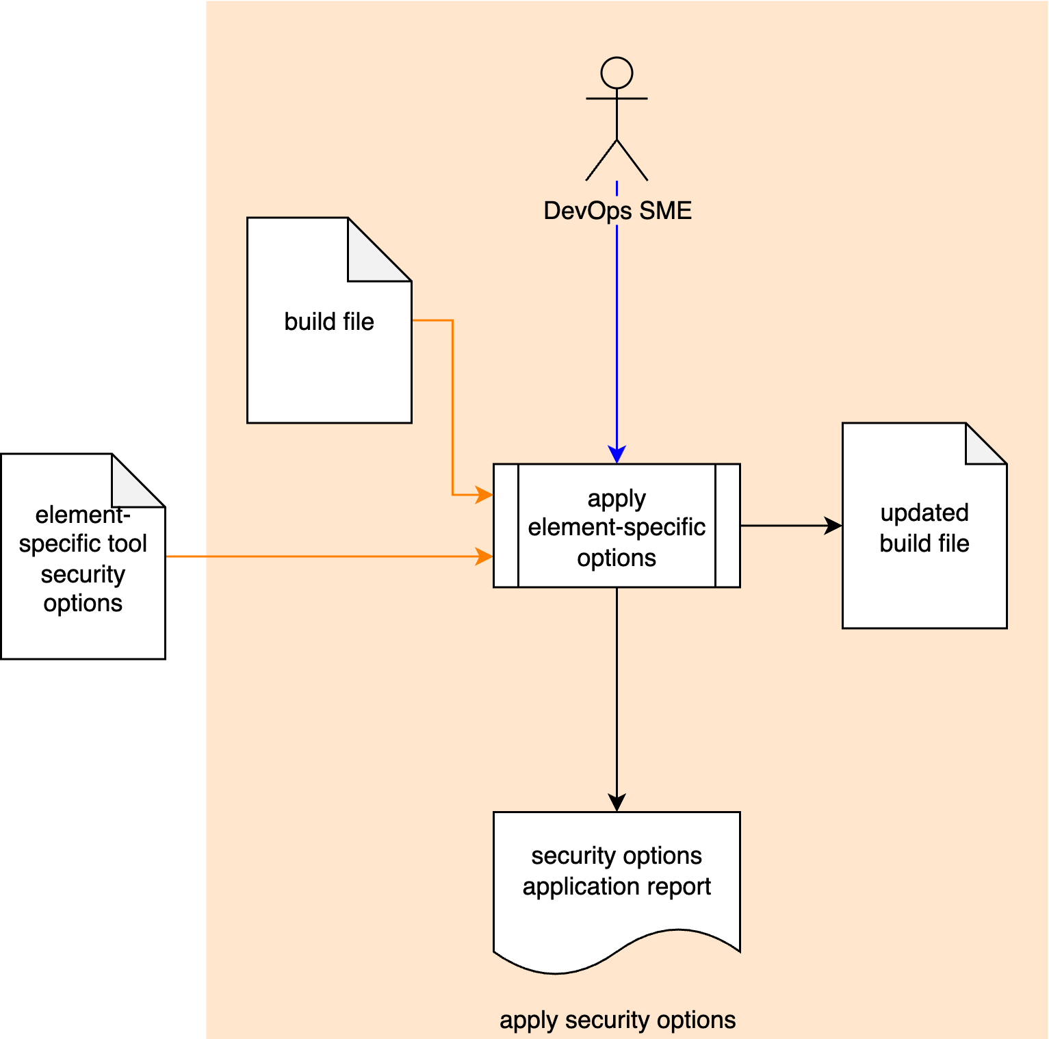
Using the Element-specific Tool Security Options and Build File, the DevOps SME applies the selected settings to the appropriate section of the Build File. An Updated Build File is created and a Security Options Application Report is generated.

Methodology
The methodology to be used for selection of element-specific tool cybersecurity options is straightforward. The DevOps SME modifies the build settings as specified in the Element-specific Tool Security Options. This is the output from the Secure Settings – Select Options Procedure ^{[4]} and may be embodied as detailed in the AVCDL element-specific tool cybersecurity options template ^{[3]}.
Note: Depending on the settings added or modified, there may be a negative impact on build time and/or execution speed. These impacts should be accounted for in any timing limiters applied to the build as a whole.

Exit Criteria
This procedure is considered complete once the generated output has been entered into the organization’s DMS as a document of record.
Note: The processes and procedures for entering documents into the DMS, or the updating thereof, are outside the scope of this document.
Note: It is recognized that the build file is stored and managed within the context of the revision control system. It is recommended that within regulated domains that an immutable artifact (Security Options Application Report) documenting the application of the Element-specific Tool Security Options be entered into the DMS for audit purposes.

References
- AVCDL (AVCDL primary document)
- Secure Settings Document (AVCDL secondary document)
- AVCDL element-specific tool cybersecurity options template (AVCDL template)
- Secure Settings – Select Options Procedure (AVCDL tertiary document)

